SwissCenter Installation
SuSE Linux 9.3 Guide

Author: Robert Taylor (Swiss)
Creation Date: 3rd July 2005
Last Updated: 3rd July 2005
Version: Draft A

Contents

Before You Begin 3
Installing Apache, MySQL and PHP 4
Installing SwissCenter 5
Installing the SwissCenter Code 5
Starting MySQL 5
Configuring Apache 5
Starting Apache and MySQL automatically. 6
Testing your Installation 7
Configuring the Showcenter to use the SwissCenter Interface. 8
Configuring the SwissCenter Interface 9

Before You Begin
The following is a list of all the software that you will need to download for a successful installation of the SwissCenter interface for the Pinnacle Showcenter:
- SwissCenter
Download from http://www.swisscenter.co.uk/
Size – 1.5Mb
Total download size is approximately 1.5 Mbytes.
Please Note: The software supplied with your Pinnacle Showcenter does not need to be installed on your computer to allow you to use the SwissCenter. However, you will need the Pinnacle software installed if you wish to upgrade the Showcenter firmware.

Installing Apache, MySQL and PHP
You should ensure that the Simple Webserver with Apache2 package selection has been installed on your machine by running YaST and clicking on the “Install and Remove Software” icon under the “Software” category:
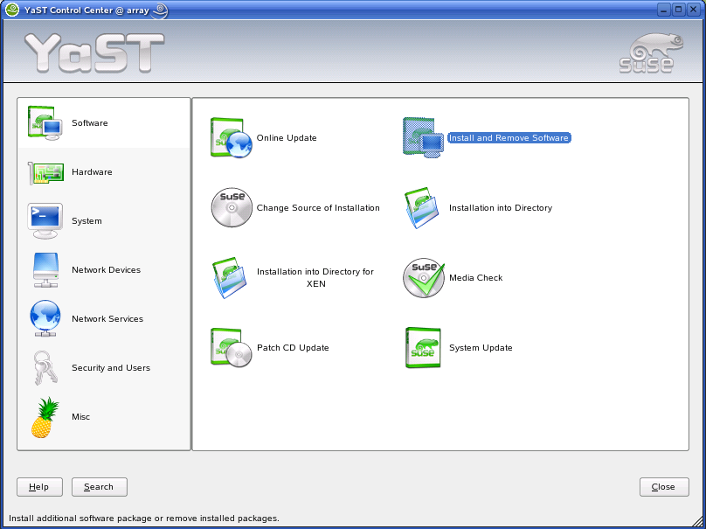
This will launch the YaST Package manager where you can see details on all the packages that are currently installed on your system, and those that are available from your installation CDs/DVD.
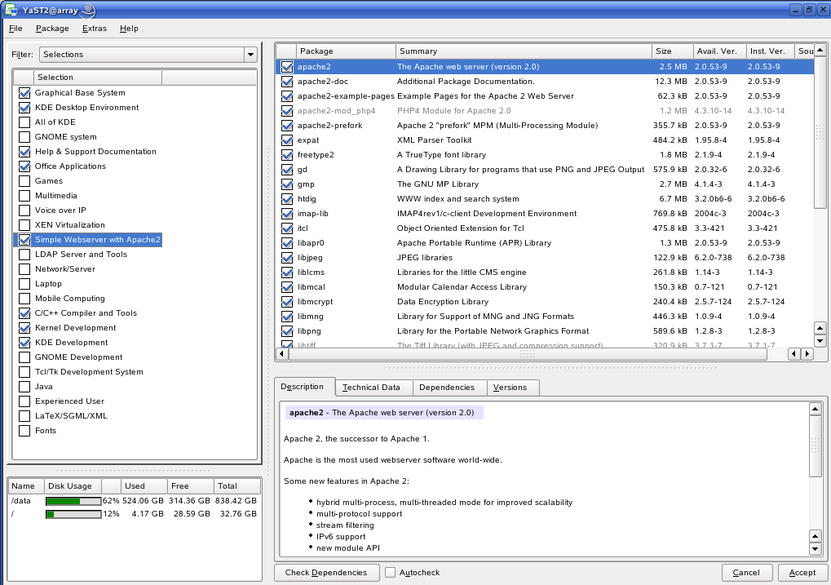
Choose the “Selections” filter from the drop-down list in the top left corner of the dialog box, and then tick the “Simple Webserver with Apache2” option (shown highlighted in the screenshot below). This will ensure that Apache, PHP and MySQL are all installed on your system.
Click Accept to install the packages from your original installation media.

Installing SwissCenter

Installing the SwissCenter Code
Download the SwissCenter Zip file to the /tmp directory and issue the following commands as the root user:
mkdir /srv/www/swisscenter
cd /srv/www/swisscenter/
unzip /tmp/swisscenter.zip
chown -R wwwrun:www .

The directory shown in red is only a suggested installation directory for the SwissCenter files and that you may use a different directory if you wish provided that you make sure the apache configuration (see below) references the same directory.

Starting MySQL
Start the MySQL Service by issuing the following command (as root):
/etc/init.d/mysql start

Configuring Apache
Using a text editor such as vi, create a file in /etc/apache2/vhosts.d called swisscenter.conf with the following contents:
# SwissCenter Apache Virtual Host Configuration file

Listen 8080
<VirtualHost _default_:8080>
DocumentRoot "/srv/www/swisscenter"
<Directory "/srv/www/swisscenter">
Options Indexes FollowSymLinks MultiViews
AllowOverride None
Order allow,deny
Allow from all
</Directory>
<IfModule mod_dir.c>
DirectoryIndex index.html index.php
</IfModule>
</VirtualHost>
Start the Apache2 Service by issuing the following command (as root):
/etc/init.d/apache2 restart

Starting Apache and MySQL automatically.
Launch YaST and click on the “System Services (Runlevel)” icon under the “System” category:
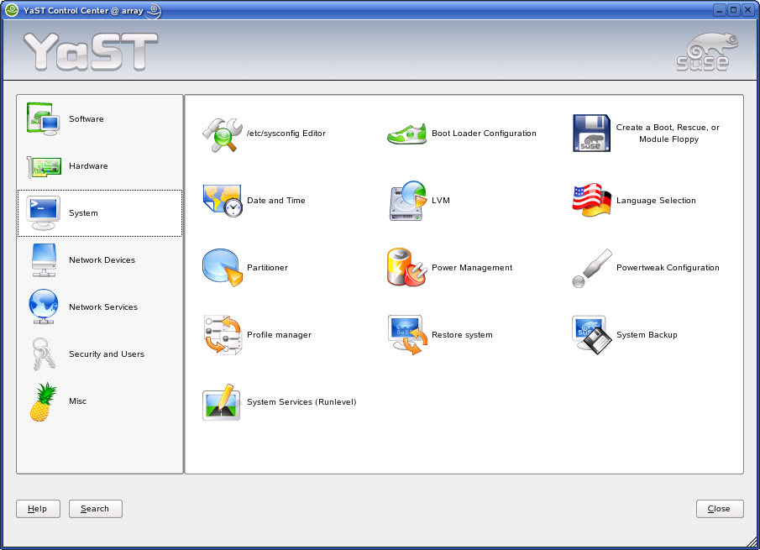
In the system services editor, select the “Apache2” service and click on Enable. Next, scroll down the list and select the MySQL service and click Enable. This will start both processes (if they are not already started) and also configure them to start automatically whenever the machine is rebooted.
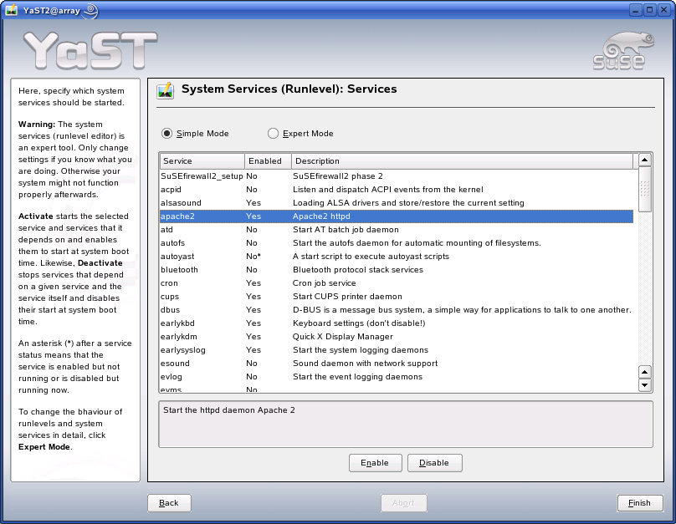
Finally, click Finish.

Testing your Installation
If you followed all of the instructions above then you can now test your configuration by opening Internet Explorer and going to the following location:
http://localhost:8080/config
If all is well, then you will see the SwissCenter Configuration Utility appear:
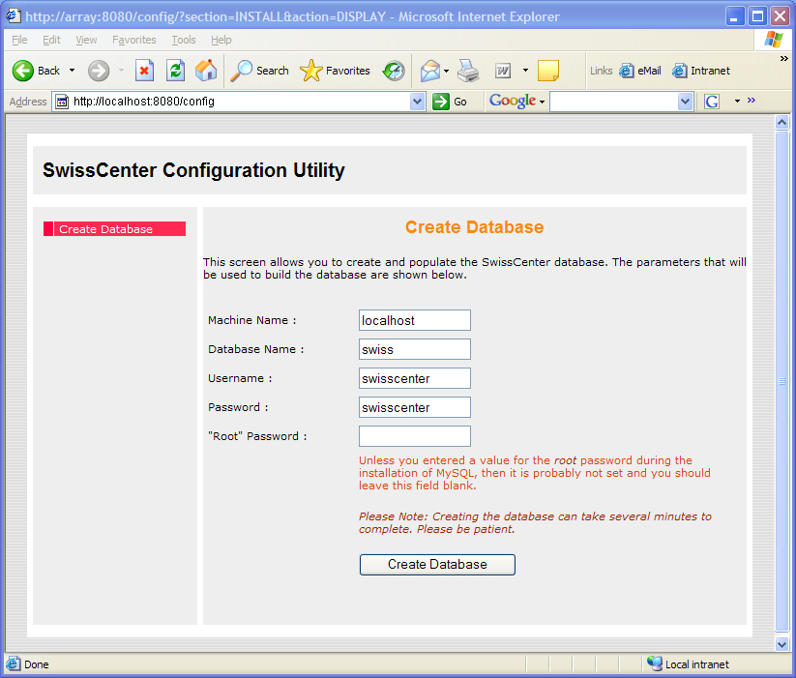

Configuring the Showcenter to use the SwissCenter Interface.
When you turn on your Showcenter box, it will not automatically detect the SwissCenter interface, and so you need to manually add it. On the screen that first appears (shown below) move the cursor over to the Add Server button and press OK on the remote control.
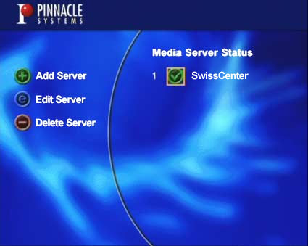
Using the numeric keys on the remote control, enter a Name for the server (eg: SwissCenter) and then the IP address of the computer that you installed the SwissCenter software onto, making sure to add ":8080" onto the end of the IP address. Also ensure that the Always connect to this server option is checked before clicking Save.
 | You can find out your IP address by clicking Start > Run and entering cmd into the dialog box that appears. Pressing OK will then bring up a command window into which your should type ipconfig and press return. Your IP address will then be displayed on the screen.

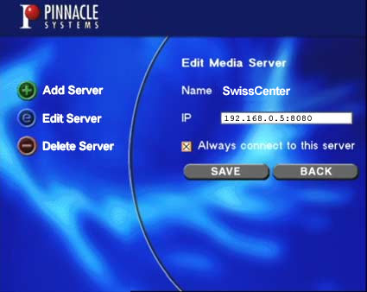

Configuring the SwissCenter Interface
The configuration of the SwissCenter Interface is identical regardless of which operating system you installed the software onto as it uses a web-based front-end. A more detailed guide on how to configure the SwissCenter is available online at www.swisscenter.co.uk , however the basic steps for getting the SwissCenter up-and-running are as follows:
Step 1
Go to the SwissCenter Configuration Utility by entering the following URL into Internet Explorer:
http://localhost:8080/config
Step 2
As this is the first time you have run the utility, you do not have a database containing all the SwissCenter configuration and therefore you should click on the menu option "Create Database".
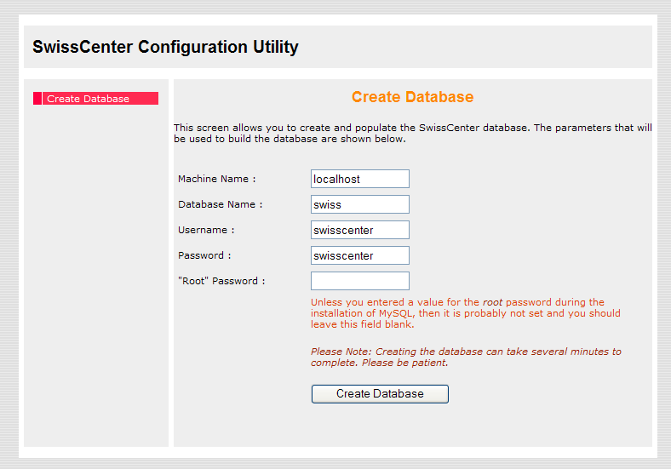
By default, MySQL will be configured without a root password and so you should just click on the Create Database Button. Please note that this can take approximately 60 seconds to complete.
If you are using an existing MySQL installation which has a root password assigned, then you will need to enter it in the form.

Step 3
When the database has been created, click on the “Media Locations” option in the menu and you will be taken to the screen shown below. This is where you specify the locations of the media files that you want to make available via the SwissCenter interface.
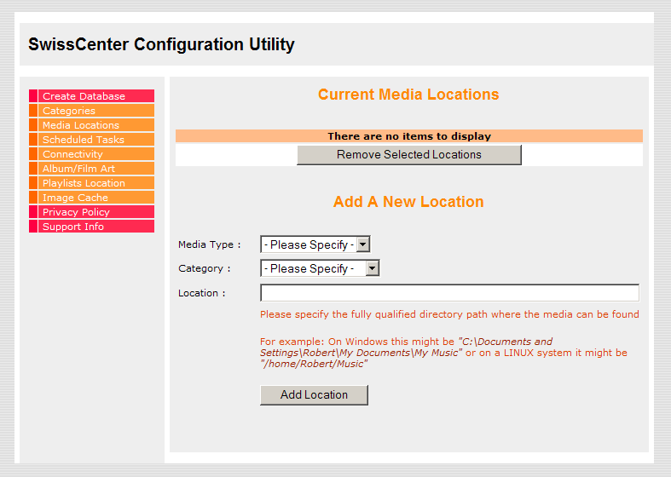
Select the type of media files that you would like the SwissCenter to search for, the Category in which they should appear and the location where the files can be found, then click on Add Location. You can add as many locations as you wish.
Finally, you need to instruct the SwissCenter to search for new media in the locations that you have just added. This is done on the ShowCenter itself, so switch it on and you should see the following screen:
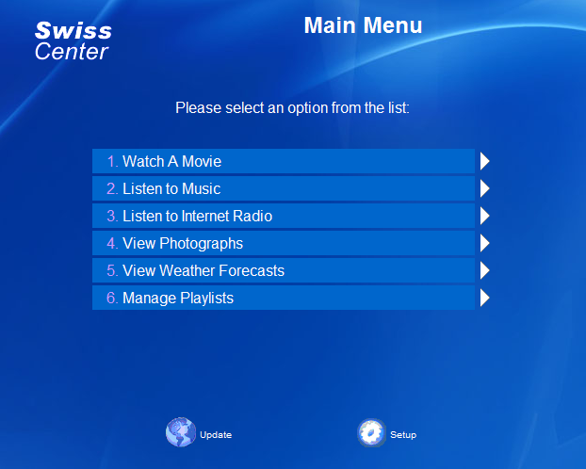
Navigate down to the “Setup” icon using the remote control and select it. You will now be presented with the Setup options:
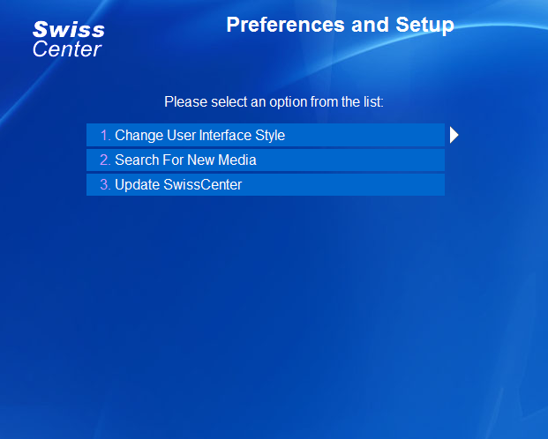
Navigate down to the “Search For New Media” option and select it. The media search will begin and you will see the following screen:
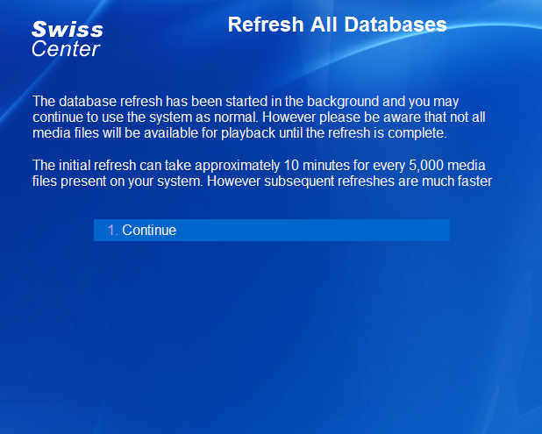
That’s it… you can now start using your SwissCenter!

